Chapter 4: Realization

4.1 Introduction

In every craftsmanship, the quality of the tools plays a decisive role in the quality of the product, and it’s the same in software development. That’s why the choice of programming tools needs to be made after an in-depth study of these tools.
After presenting the conceptual aspects of our project in the last chapter, we move on to presenting the realization of our project in this one after we present the tools that helped us bring our idea to life.

4.2 Working environment and tools

In this section we will present the software and hardware environment

4.2.1 Material Environment

During this project, we used a laptop characterized by the following:
- OS: Windows 10
- CPU:1.70GHz Intel Core i5 four cores
- RAM: 8Go
- Hard Disk: 1000GO HDD.

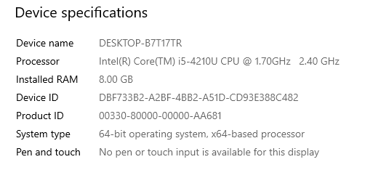
Figure 4.1: Computer characteristics

4.2.2 Software Environment

In this section, I will present the technologies chosen for my project:

Front-End
React.js is an open-source, front end JavaScript library for building user interfaces or UI components. It is maintained by Facebook and a community of individual developers and companies.
Component-Based
React allow its users to build encapsulated components that manage their own state, then compose them to make complex UIs.
Declarative
React makes it painless to create interactive UIs. After designing simple views for each state in the application, React will efficiently update and render just the right components when the date changes
Write once, Use everywhere
React components are easily re-usable in different applications.


Figure 4.2: ReactJS logo

Redux
Redux is an open-source JavaScript library for managing application state. It is most commonly used with libraries such as React or Angular for building user interfaces. Similar to (and inspired by) Facebook's Flux architecture, it was created by Dan Abramov and Andrew Clark.

Figure 4.3: Redux Logo

Bootstrap
Bootstrap is a free and open-source CSS framework directed at responsive, mobile-first front-end web development. It contains CSS- and (optionally) JavaScript-based design templates for typography, forms, buttons, navigation, and other interface components.
As of April 2021, Bootstrap is the tenth most starred project on GitHub

Figure 4.4: Bootstrap Logo
Reactstrap
Reactstrap is a component library for reactjs. It provides inbuilt Bootstrap components that make easy to create UI with its self-contained components that’s provide flexibility and inbuilt validations. Reactstrap is similar to Bootstrap, but it has self-contained components. It’s easy to use and support Bootstrap 4.

Figure 4.5: Reactstrap Logo

Back-End

Node.js
Node.js is an open-source, cross-platform, back-end JavaScript runtime environment that runs on the V8 engine and executes JavaScript code outside a web browser.Node.js lets developers use JavaScript to write command line tools and for server-side Scripting-running scripts server-side to produce dynamic web page content before the page is sent to the user’s web browser.
Node.js represents a “JavaScript everywhere ‘paradigm, unifying web-application development around a single programming language, rather than different languages for server-side and client-side scripts.
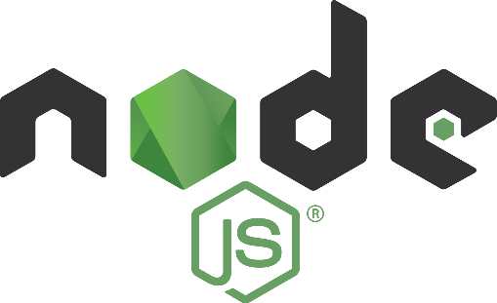
Figure 4.6: Node.js Logo

Express.js
Express.js, or simply Express, is a back end web application framework for Node.js, released as free and open-source software under the MIT License. It is designed for building web applications and APIs.[3] It has been called the de facto standard server framework for Node.js.[4]

Figure 4.7: Express.js logo

MongoDB
MongoDB is a source-available cross-platform document-oriented database program. Classified as a NoSQL database programming uses JSON-like documents with optional Schemas

Figure 4.8: MongoDB logo

Visual Studio Code
Visual Studio Code is a source-code editor made by Microsoft for Windows, Linux and macOS.[9] Features include support for debugging, syntax highlighting, intelligent code completion, snippets, code refactoring, and embedded Git. Users can change the theme, keyboard shortcuts, preferences, and install extensions that add additional functionality.

Figure 4.9: Visual Studio Code Logo

StarUml
StarUML is a UML tool by MKLab. The software was licensed under a modified version of GNU GPL until 2014, when a rewritten version 2.0.0 was released for beta testing under a proprietary license. After being abandoned for some time, the project had a revival to move from Delphi to Java/Eclipse and then stopped again.

Figure 4.10: StarUML Logo

Draw.io
diagrams.net (formerly draw.io) is free online diagram software. You can use it as a flowchart maker, network diagram software, to create UML online, as an ER diagram tool, to design database schema, to build BPMN online, as a circuit diagram maker, and more. draw.io can import. vsdx, Gliffy™ and Lucidchart™ files .

Figure 4.11: draw.io Logo
Git
Git is software for tracking changes in any set of files, usually used for coordinating work among programmers collaboratively developing source code during software development. Its goals include speed, and support for distributed, non-linear workflows (thousands of parallel branches running on different systems)

Figure 4.12: Git Logo

Postman
Postman is an interactive and automatic tool for verifying the APIs of your project. Postman is a Desktop application for interacting with HTTP APIs. It presents you with a friendly GUI for constructing requests and reading responses. It works on the backend, and makes sure that each API is working as intended

Figure 4.13: Postman Logo

Microsoft Word
Microsoft Word is a word processor developed by Microsoft. It was first released on October 25, 1983,[6] under the name Multi-Tool Word for Xenix systems.[7][8][9] Subsequent versions were later written for several other platforms .

Figure 4.14: Microsoft Logo

Conclusion
In this chapter, we described the development environment in which we developed our application, as well as the used frameworks. Followed by an overview of the work carried out through screenshots of the application’s interfaces.

General conclusion and perspectives

The period of internship in the Mega-DEV company was quite rewarding for me. As future software developer, this internship has allowed me to learn new technologies, new methodologies and new working environment.

The main objective of the project is to create a workout management system as per the requirements and specifications developed with Mega-DEV. The solution englobes different features such as Workout Management, Chat…

The benefits of this work go beyond the programming knowledge as per the use of modern technologies such as React.js and Express.js frameworks, in fact the Agile project management approach used is a topnotch methodology that allowed us to ensure that bugs were fixed in due time and wave was tailored through every iteration.

Even though the achieved result satisfies the requirements, theres room for improvements, such as adding a mobile version of the application, and to add more interactions between the users.

Among the different lessons picked up during this work, is how to plan ahead and manage the time effectively to achieve the tasks before the deadlines.

Bibliography
- Three tier architecture. Accessed 2021-05-15 https://www.ibm.com/cloud/learn/three-tier-architecture
- Visual Studio Code: Accessed 2020-06-11. URL: https://en.wikipedia.org/wiki/Visual_Studio_Code
- Redux: Accessed 2021-04-30.URL: https://en.wikipedia.org/wiki/Redux_(JavaScript_library)
- Redux: Accessed 2021-04-30. URL: https://en.wikipedia.org/wiki/Bootstrap_(front-end_framework)
- Reactstrap. Accessed 2021-02-30. url: https://www.c-sharpcorner.com/article/reactstrap-in-reactjs/
- Express.js: Accessed 2021-03-22. URL: https://en.wikipedia.org/wiki/Express.js
- StarUML: Accessed 2021-04-05. URL: https://en.wikipedia.org/wiki/StarUML
- Draw.io: Accessed 2021-04-12. URL: https://app.diagrams.net/
- Git: Accessed 2021-05-30. URL: https://en.wikipedia.org/wiki/Git
- Redux: Accessed 2021-06-12. URL: https://www.axelerant.com/resources/team-blog/api-testing-with-postman
- Agile methodology: Accessed 2021-02-25. ://en.wikipedia.org/wiki/Agile_software_development
- React Design pattern Accessed: https://www.educative.io/blog/react-design-patterns-best-practices

